Direction-Aware Routing via Reference-Free Relative Localization in Wireless Sensor Networks
Kanak Patel1* and Himanshu S. Mazumdar2
1,2 Research and Development Center, Dharmsinh Desai University, Nadiad 387001, Gujarat, India
*Corresponding author: kanakpatel.rnd@ddu.ac.in | Contributing: hsmazumdar@ddu.ac.in

Abstract
This paper revisits a practical question for wireless sensor networks (WSNs): is full metric localization necessary for direction-aware routing? We argue that directional consistency—not absolute position accuracy—is the functional requirement for greedy forwarding. We present a lightweight, reference-free relative localization procedure based on expected distance constraints and an asymmetric neighbor-attraction update. Local updates use only neighbor state; however, the present simulator applies a global scale-normalization step for numerical stability, which we explicitly treat as a simulation convenience rather than a claim of fully decentralized operation. Convergence is established locally (each selected violated edge strictly shrinks) and treated globally as an empirically observed relaxation process, not a completed Lyapunov proof. We present a controlled density-versus-transmission-range study (600 trials) showing that higher node density enables substantially lower radio range—and thus lower transmit energy—while maintaining a usable neighbor degree (≈8–10). On an 800×800 canvas with neighbor cap k=10, the minimum Tx (% of diagonal) meeting degree ≥8 and full connectivity falls from 20% at N=50 to 8% at N=300, reducing a path-loss energy proxy (η=2.5) by about an order of magnitude. We further restore a Mode A topological-consistency evaluation with logged artifacts: for N=250 the median relative edge-direction MAE is ≈2.9° with directional correctness ≈94.5%. We clarify the distributed-scope ambiguity of relative maps (similarity invariance implies some network-wide agreement on scale/frame) and outline deployment options (gossip of centroid/scale, or tapered dissemination of link summaries) without asserting unimplemented flood or NS-3 results.
Keywords: Wireless sensor networks; relative localization; direction-aware routing; node density; transmission range; energy-aware deployment; anchor-free embedding.

1 Introduction
In WSNs, geographic or direction-aware routing (e.g., GPSR [1]) has long relied on node positions, so localization is often treated as a prerequisite. Prior work shows greedy routing can tolerate position error if directional relationships remain consistent [14,15]. Nonetheless, many localization schemes still optimize metric accuracy and introduce anchors, ranging hardware, or centralized computation [2–7].
We study a lighter objective: construct a relative embedding that preserves topology and direction up to similarity (translation, rotation, uniform scale), using only expected distance constraints and local asymmetric updates. The intended consumer is direction-aware forwarding, not surveying-grade localization.
Contributions:
- Routing-centric formulation — directional consistency as the primary objective for greedy forwarding.
- Asymmetric neighbor-attraction algorithm with a rigorous local reduction lemma and an explicitly empirical global convergence statement.
- Honest distributed-scope statement — local updates are neighbor-only; global normalization in the current simulator is disclosed as a limitation, with deployment alternatives sketched.
- Density–Tx deployment study — denser deployments permit lower Tx (energy) while preserving usable degree and connectivity (600 trials).
- Mode A topological consistency evaluation — auditable angle-MAE / directional-correctness table and N=250 preservation figures.
- Auditable experiment artifacts — CSVs, figures, and captions are provided in the GitHub repository (Results/ directory).
Organization: Section 2 reviews related work. Section 3 states the model. Section 4 describes the algorithm (including expanded normalization discussion). Section 5 presents convergence status. Section 6 reports experiments: density–Tx and Mode A localization quality. Section 7 discusses routing use. Section 8 concludes with limitations and future work.

2 Related Work
Range-based methods [2–4] estimate distances from RSS/ToA/TDoA but are sensitive to multipath and typically need anchors or calibrated hardware. Range-free methods [5–7] reduce hardware cost yet often still depend on anchors and idealized density. Relative and MDS-style embeddings [4,8–10] remove absolute anchors but frequently retain distance estimates or centralized computation. Virtual coordinate systems [16–18] target routing stretch and delivery with abstract coordinates. Our focus is closer to routing-oriented relative maps: enforce soft distance-order constraints sufficient for angular consistency, without claiming metric reconstruction.
Table 1 compares paradigms along telecom-relevant axes. We do not claim that the proposed method is "fully distributed" in the strict sense while a global normalization step is used in simulation.
Table 1. Comparison of localization approaches along telecommunication-relevant axes
Approach | Anchors? | Ranging? | Distributed? | Training? | Routing-oriented?
Range-based [2–4] | Yes | Yes | Partial | No | No
Range-free / DV-Hop [5–7] | Yes | No | Yes | No | No
MDS-based [4,8–10] | No | Yes | Often centralized | No | No
Learning / GNN-style [11] | No | Often yes | Varies | Yes | No
Virtual coordinates [16–18] | No | No | Yes | No | Partial
Proposed (this work) | No | No* | Partial† | No | Yes

*Expected distances may come from planned spacing or hop proxies, not physical ranging. †Local asymmetric updates are neighbor-only; the current simulator applies global scale normalization after batches of updates.

3 System Model and Problem Formulation

3.1 Network model
We model the network as an undirected communication graph G=(V,E). Each node i∈V maintains a virtual position p_i∈R². Positions need not equal geographic coordinates. Nodes exchange state only with graph neighbors. Connectivity of G is assumed for the analysis of a single connected component; sparse regimes are studied empirically in Section 6.3.

3.2 Expected distance constraints
For each edge (or stored neighbor pair) the algorithm uses an expected distance d*_ij. Two acquisition modes are distinguished:
Mode A — Planned geometry (validation baseline). In structured deployments, nominal spacing is known from layout. Constraints are taken from reference geometry (as in the present WinForms/Python simulators that build a k-nearest unit-disk distance matrix from a grid-with-jitter layout).
Mode B — Connectivity-derived (ad-hoc). When no layout is known, hop-count proxies can supply ordered expected distances. Hop radius h and scale α are discussed; we avoid circular evaluation (constraints and scoring must not reuse the same connectivity realization without an independent reference).

3.3 Problem statement
Given G and constraints {d*_ij}, design a reference-free procedure such that virtual positions become mutually consistent with the constraints up to similarity, using local interactions, and yielding directional cues adequate for greedy forwarding.

4 Proposed Localization Algorithm

4.1 Asymmetric neighbor attraction
When node u is selected and neighbor v violates ||p_u−p_v|| > d*_uv, only v is moved toward u by a fraction β∈(0,1) of the displacement (asymmetric update). Satisfied constraints are left unchanged. This one-sided correction is simple and matches the implementation used in our experiments (β=0.3 in the density–Tx study).

4.2 Scale normalization and distributed-scope clarity
Because embeddings are defined only up to similarity (translation, rotation, and uniform scale), absolute coordinates are ambiguous without some shared frame. Asymmetric neighbor updates are strictly local, yet a numerically stable relative map still requires network-wide agreement on scale (and typically origin). This is the central ambiguity of “distributed processing versus normalization.”
In the present simulator, normalization periodically rescales the configuration to a fixed canvas occupancy (90% span) using global bounding-box information. That step is a simulation convenience for stability and visualization; it is not a claim of fully decentralized field operation. Independent per-axis scaling (as in the WinForms GUI) is avoided in the topology-quality study, which uses uniform (similarity) scaling so that angles remain meaningful under the similarity model.
Deployment designs (not claimed as implemented experiments in this manuscript) include: (a) gossip / consensus averaging of local centroid and scale estimates [19]; and (b) dissemination of link or RSS-summary tables among neighbors until no new information is added, so that each node eventually holds a consistent global view—or receives already-globalized summaries early in the bootstrap. For mobile networks the same process is continual, with update frequency expected to drop as the localization table stabilizes. We do not assert a full N×N RSS flood in the current codebase; lightweight gossip of moments is preferred over dense table flooding.

4.3 Algorithm sketch
Initialize positions (random, scrambled, or MDS on expected-distance shortest paths for Mode A quality runs). Repeatedly: sample a node; relax violated neighbor constraints asymmetrically; optionally normalize; stop when no sampled batch finds a violation (hard stop) or when residual violation falls below a tolerance (soft stop). Neighbor lists are truncated to the k nearest contacts inside radio range R (Tx).

5 Convergence Status
We separate what is proved from what is observed, addressing concerns that some prior versions over-promised Lyapunov-style global guarantees.

5.1 Lemma 1 (local constraint reduction)
If ||p_u−p_v|| > d*_uv and p_v is updated toward p_u by factor β∈(0,1), then the Euclidean length of edge (u,v) strictly decreases. Proof sketch: the new distance equals (1−β)·||p_u−p_v|| < ||p_u−p_v||. Thus every selected violated edge makes local progress.

5.2 Global energy is not claimed monotone
Define E(P)=Σ_{(i,j)} max(0, ||p_i−p_j||−d*_ij)^2. A local fix of (u,v) may increase violations on other edges incident to v. Therefore we do not claim that E decreases after every elementary update. Empirically, randomized relaxation drives residual violation downward under consistent constraints, but a full asynchronous stochastic convergence proof is left open.

5.3 Statement of theoretical status
Rigorous: Lemma 1 (local reduction); E(P)≥0 with equality only if all soft constraints are met.
Empirical: repeated updates reduce aggregate violation in the logged experiments; hard batch-wise finish flags can be rare in dense, high-degree regimes even when residuals are small—hence soft criteria in Section 6.4.
Not claimed: global Lyapunov decrease; uniqueness of the global minimizer; fully decentralized normalization as an implemented and measured protocol.

6 Experimental Evaluation

6.1 Simulation setup (auditable matrix)
The density–Tx study uses a headless Python controller mirroring the WsnMap distance-constraint mode. Fixed controls: canvas 800×800 px; attraction β=0.3; 100 random node updates per tick; maximum 250 ticks; path-loss exponent η=2.5 for the energy proxy (R/diag)^η. Swept factors:
Factor | Values | Role
N (nodes) | 50, 100, 150, 200, 300 | Density on fixed area
Tx (% diagonal) | 5, 8, 10, 12, 15, 20, 25, 30 | Radio range / Tx proxy
k (neighbor cap) | 6, 10, 12 | Stored neighbors (txRange)
Seeds | 0…4 | Five Monte-Carlo repeats

Table 2. Input parameter matrix for the density–versus–transmission-range study (600 trials). Artifacts: Results/param_matrix.csv and Results/results_raw.csv.
Nodes are placed on an approximately square grid with intra-cell jitter. Radio neighbors are all nodes within Tx distance, truncated to the k nearest. Soft success requires: connected graph (no isolates), mean stored degree ≥6, and mean constraint violation ≤1 px after the run.

6.2 Density versus transmission range (new findings)
Lower Tx saves energy only if density keeps average degree high enough for localization and routing. We therefore minimize Tx subject to mean degree ≥8 and full connectivity (k=10 primary).
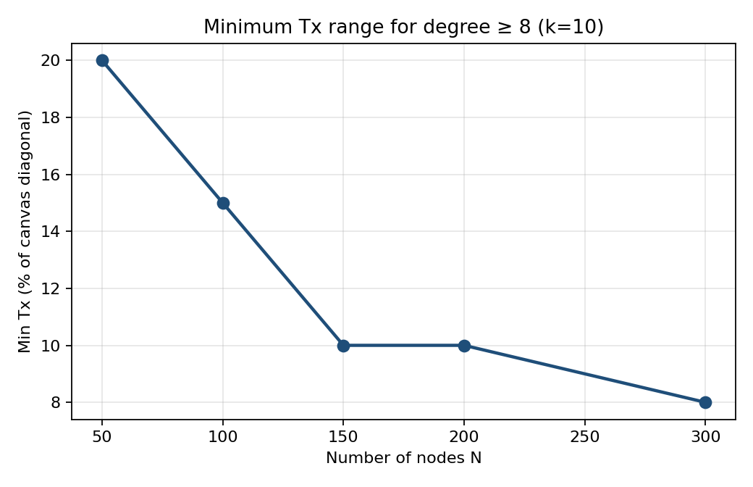
Fig. 1. Minimum Tx (% of canvas diagonal) versus node count N for mean stored degree ≥8 and a connected graph (k=10). Higher density reduces the feasible Tx percentage.
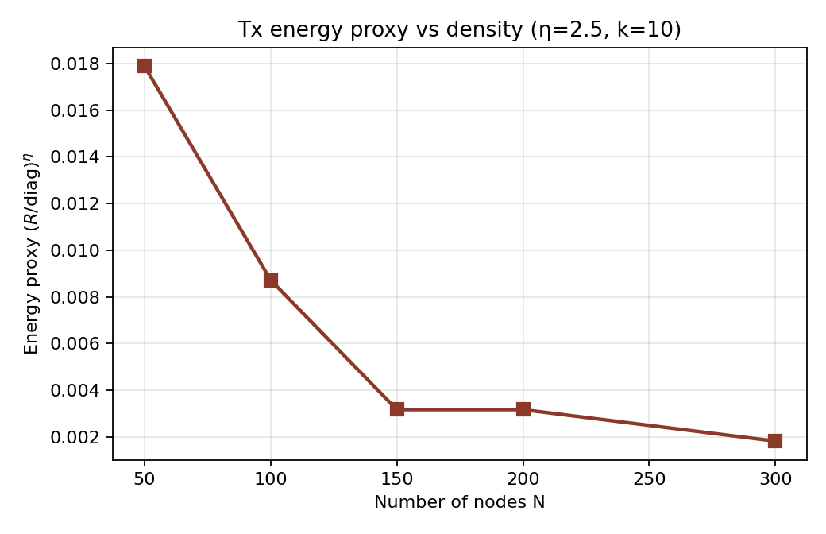
Fig. 2. Transmission-energy proxy (R/diag)^η (η=2.5) at the energy-optimal Tx of Fig. 1 versus N (k=10). Density increase yields roughly an order-of-magnitude drop in the proxy from N=50 to N=300.
Table 3. Energy-optimal Tx versus node density (k=10, target mean degree ≥8, connected). Soft converge rate uses the Section 6.1 criterion.
N | Density (1/px²) | Min Tx % | Energy proxy | Soft conv. | Mean degree
50 | 7.81e-05 | 20 | 0.0179 | 100% | 8.76
100 | 1.56e-04 | 15 | 0.0087 | 60% | 9.33
150 | 2.34e-04 | 10 | 0.0032 | 20% | 8.12
200 | 3.13e-04 | 10 | 0.0032 | 40% | 9.52
300 | 4.69e-04 | 8 | 0.0018 | 20% | 9.52

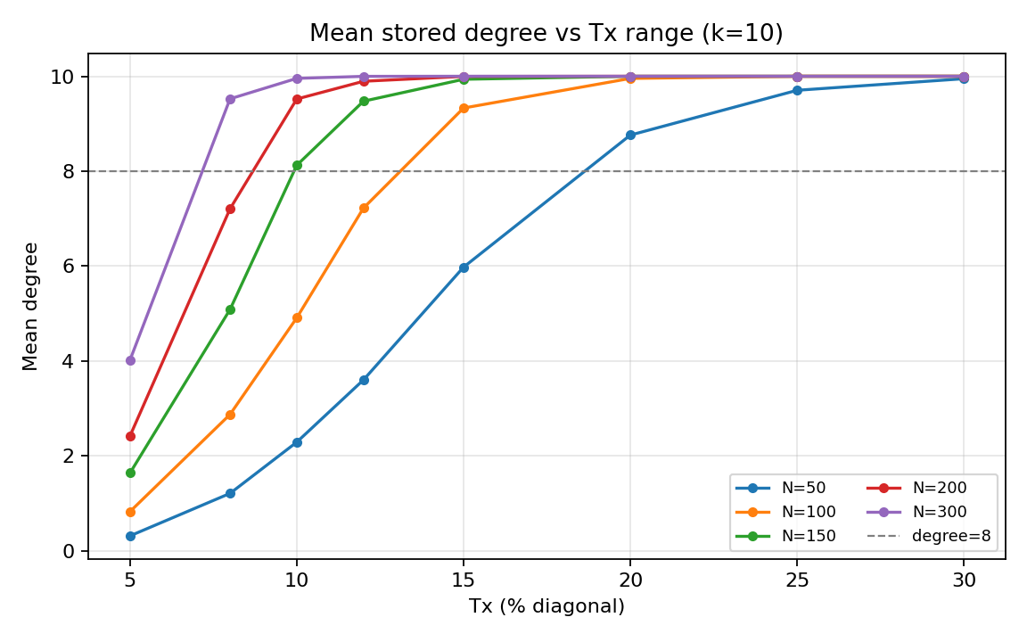
Fig. 3. Mean stored degree versus Tx for several N (k=10). The dashed reference at degree 8 is the deployment design target; denser nets reach it at lower Tx.
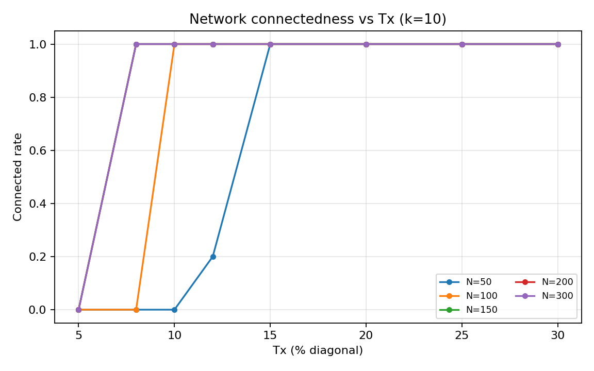
Fig. 4. Connectedness rate versus Tx for several N (k=10). Connectivity is a prerequisite for reliable relative localization.
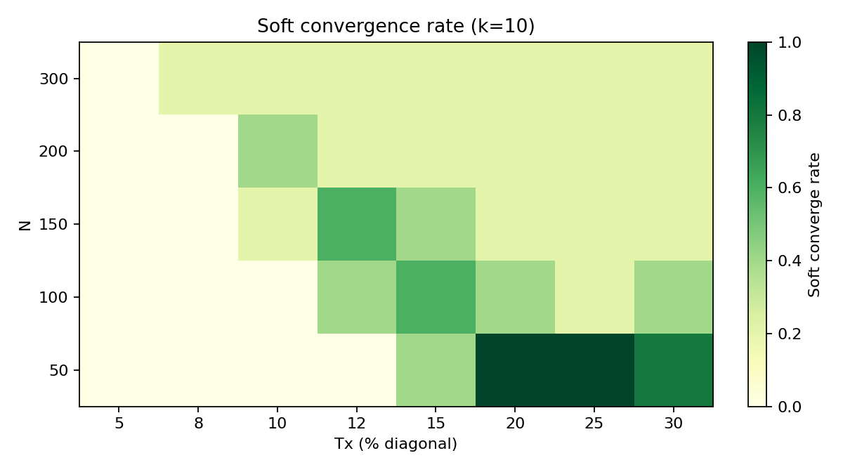
Fig. 5. Soft-convergence rate versus N (rows) and Tx (columns), k=10. Soft success requires connectivity, degree ≥6, and residual violation ≤1 px.
Deployment takeaway: raising density allows cutting radio range while holding degree near 8–10. Over-provisioning Tx in dense networks wastes energy and admits weak, long links that add little localization value once k neighbors are already available.

6.3 Sensitivity to neighbor cap k
Table 4. Minimum Tx for mean degree ≥8 across neighbor caps. For k=6 the degree-8 target is unreachable because stored degree cannot exceed k (entries marked —).
N | k=6 | k=10 Min Tx% | k=12 Min Tx%
50 | — | 20 | 20
100 | — | 15 | 15
150 | — | 10 | 10
200 | — | 10 | 10
300 | — | 8 | 8

Thus k≈10 remains a practical operating point: large enough for stable maps, small enough to avoid distant weak neighbors. Increasing k from 10 to 12 does not reduce the energy-optimal Tx further in this matrix.

6.4 Hard versus soft convergence
A hard stop that requires an entire random batch to find zero violations can fail to trigger even when residuals are small, especially at high degree. Soft criteria (violation ≤1 px with adequate degree and connectivity) better match engineering stopping rules. Sparse, very low-Tx graphs may “hard-converge” trivially because few constraints exist; such cases are excluded from soft success by the degree≥6 rule.

6.5 Localization quality and topological consistency (Mode A)
Protocol (Mode A): planned geometry supplies expected distances; classical MDS initialization on shortest-path completion of those distances; short asymmetric-attraction refine; uniform (similarity) normalization. Metrics after Procrustes alignment: black-guideline edge-direction MAE / SD / CV, and directional correctness (fraction of greedy angular forwarding decisions whose chosen neighbor lies within ±30° of the true destination bearing in the reference). Reported table values are trial medians (20 seeds for N<1000; 10 seeds for N≥1000). Cold-start random/scrambled initialization alone is multimodal under one-sided attraction; MDS init is therefore documented as the stable Mode A quality protocol used here.
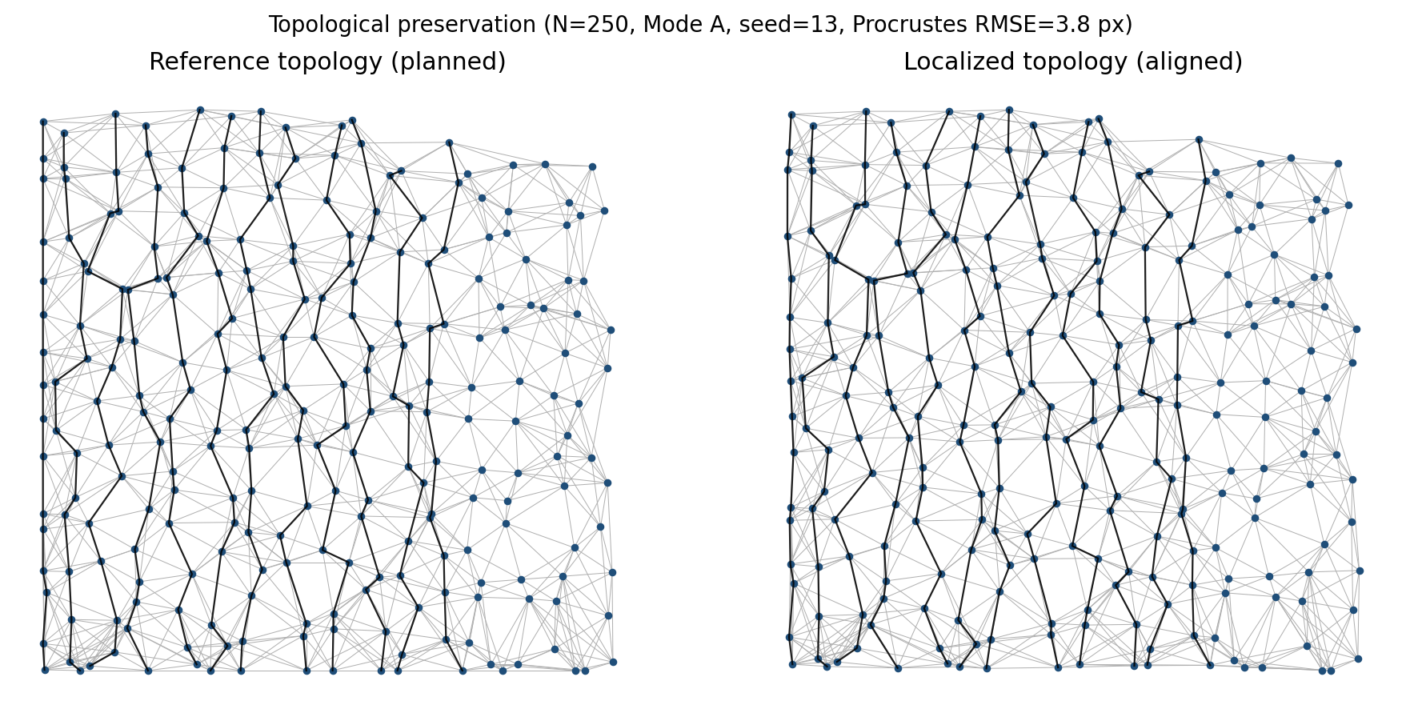
Fig. 6. Topological preservation in a 250-node network (Mode A; MDS init + attraction refine; uniform normalize; seed=13). Left: reference topology; right: localized topology after similarity (Procrustes) alignment. Gray: communication edges; black: column guidelines. Procrustes RMSE ≈ 3.8 px.
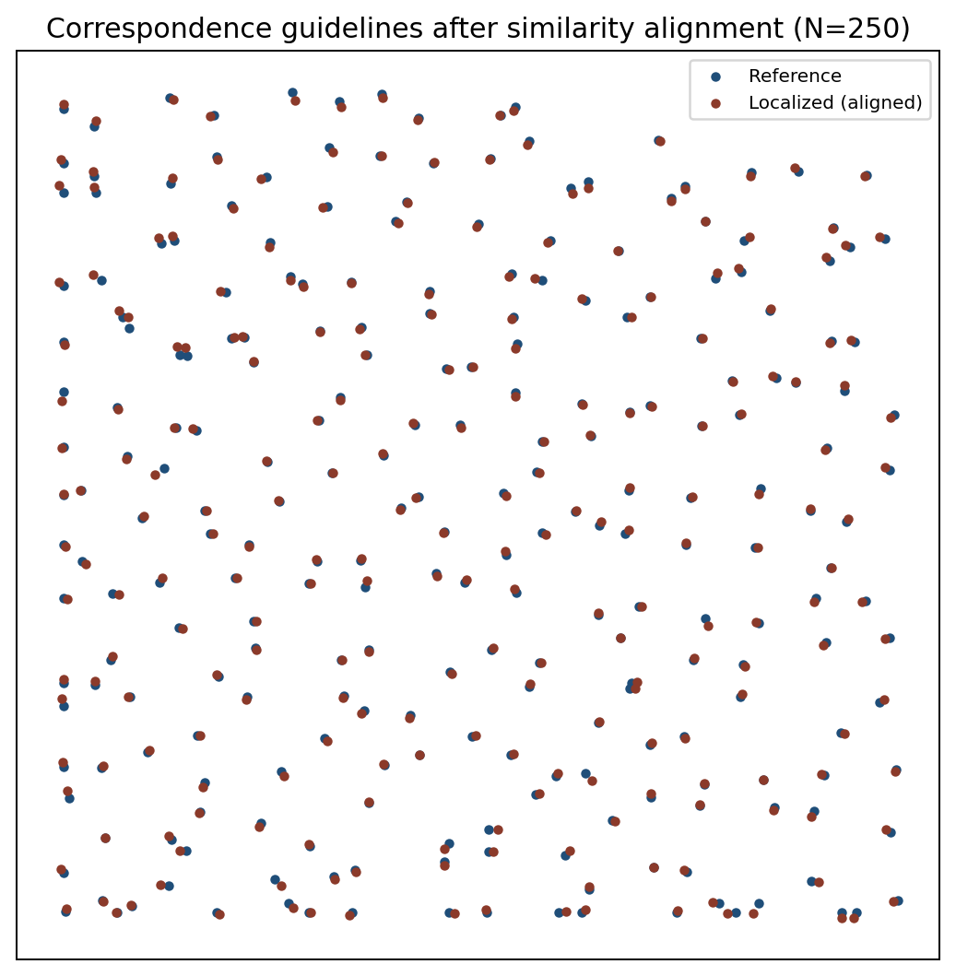
Fig. 7. Correspondence guidelines after Procrustes alignment (N=250, same trial as Fig. 6): black segments join reference nodes to localized counterparts (subsampled).
Table 5. Topological consistency across network sizes (black-guideline angle analysis). Medians over seeds; success = fraction of trials with MAE < 6°. Artifacts: Results/table_topology_angle_mae.csv, topology_quality_raw.csv.
Nodes | Ref. cols | SD [°] | CV [%] | MAE [°] | Dir. corr. | Success <6° | Assessment
25 | 5 | 5.90 | 80.7 | 7.34 | 98.8% | 45% | Well Achieved
64 | 8 | 8.22 | 82.2 | 9.30 | 97.3% | 40% | Well Achieved
100 | 10 | 27.4 | 74.3 | 45.4* | 96.8% | 50% | Needs Attention*
250 | 16 | 2.66 | 91.8 | 2.86 | 94.5% | 100% | Excellent
500 | 23 | 2.89 | 91.3 | 3.11 | 94.8% | 95% | Excellent
750 | 28 | 3.03 | 95.0 | 3.15 | 94.0% | 95% | Excellent
1000 | 32 | 3.46 | 99.3 | 3.33 | 93.3% | 100% | Excellent
1500 | 39 | 3.38 | 98.3 | 3.40 | 91.3% | 90% | Excellent
2000 | 45 | 3.49 | 102.4 | 3.49 | 93.8% | 80% | Excellent

*At small N, classical MDS on sparse shortest-path distances is occasionally unstable (near-orthogonal embeddings); medians can be pulled by failed seeds even when best-seed MAE is low. For N≥250 the median MAE remains below 4° with high success rates—adequate for direction-aware routing. Primary visual evidence is Fig. 6 (N=250).

7 Integration with Direction-Aware Routing
Given relative positions, a node computes the destination direction in the virtual frame and selects the neighbor minimizing angular deviation (greedy directional forwarding). Because similarity transforms preserve angles, an embedding that is consistent up to similarity supports the same angular decisions as a reference layout.
Routing failures in greedy schemes are often topological voids (local minima), not pure localization error [1,14]. Perimeter/face recovery remains complementary. We do not claim new NS-3 packet-level campaigns; integrating relative coordinates into GPSR-style stacks is future work. The density–Tx results matter for routing because connectivity and degree govern both embedding quality and forwarding options: energy-optimal Tx must still keep the graph usable for greedy progress.

8 Conclusion, Limitations, and Future Work

8.1 Conclusion
Relative, reference-free embeddings aimed at directional consistency are a credible lightweight alternative to metric localization for direction-aware WSN routing. The asymmetric attraction rule offers clear local progress; global convergence remains empirically supported rather than fully proved. The density–Tx study provides deployment guidance (raise density to cut Tx while holding degree ≈8–10). The Mode A topology-quality study shows that, under a documented MDS-init protocol, angular errors of a few degrees and ~94% directional correctness are attainable at N=250 with auditable artifacts. Normalization remains a disclosed simulation dependence; distributed alternatives are outlined for future measurement.
Table 6. Key findings (telecom perspective).
Finding | Evidence | Implication
Directional objective supported (Mode A) | §6.5; Figs. 6–7; Table 5 (N=250 MAE≈2.9°) | Metric survey accuracy not required for greedy direction
Min Tx falls with density | Table 3 / Figs. 1–2 (600 trials) | Deploy denser to save Tx energy
Degree target ≈8–10 | Fig. 3; k-sweep Table 4 | Cap neighbors; do not over-range
Soft stopping needed | Section 6.4 | Use residual thresholds in practice
Normalization needs shared scale/frame | Section 4.2 | Gossip or tapered dissemination = future deploy designs

8.2 Limitations
- Global scale normalization in the current simulator (not a measured gossip deployment).
- Density–Tx matrix uses Mode A constraints, fixed canvas, and N≤300.
- Topology-quality uses Mode A with MDS initialization; small-N MDS can be unstable; Mode B hop constraints remain future work.
- Hard finish flags under-report practical convergence; soft metrics are preferred.
- Packet-level routing and distributed normalization are not re-validated.
- Assumes a working connected component; extremely sparse graphs remain out of scope.

8.3 Future work
- Implement and measure gossip-based normalization [19] against the global baseline (preferred over full RSS-table flood).
- Evaluate tapered link/RSS-summary dissemination and mobile update-rate schedules as deployment options discussed in §4.2.
- Unify Mode B (hop constraints) with independent reference evaluation to avoid circularity.
- Packet-level GPSR/perimeter experiments (e.g., NS-3) comparing relative vs. true coordinates on void rates.
- Map Tx% to dBm using the log-normal model (PL0, η, σ) for radio sizing worksheets.
- Extend density–Tx sweeps to larger N and irregular obstacle maps.

Declarations
Competing interests: The authors declare no competing interests.
Funding: Not applicable.
Author contributions: Kanak Patel — conceptualization, methodology, software, experiments, writing. Himanshu S. Mazumdar — supervision of simulator design, density–Tx and normalization-scope guidance, manuscript revision.
Data availability: The source code, simulation scripts, and all experiment artifacts (CSV data files, figures, and captions) are openly available in the Results/ directory of the GitHub repository:
https://github.com/hsmazumdar/kanakpatel/WsnLocalization2026
The repository includes:
- C# and Python source code for the localization algorithm
- Experiment scripts and configuration files
- Raw and summarized CSV data used to generate all figures and tables reported in the paper
- High-resolution figures with captions

References
[1] Karp B, Kung HT (2000) GPSR: Greedy perimeter stateless routing for wireless networks. MobiCom, pp 243–254.
[2] Patwari N et al. (2005) Locating the nodes: Cooperative localization in wireless sensor networks. IEEE Signal Process Mag 22(4):54–69.
[3] Langendoen K, Reijers N (2003) Distributed localization in wireless sensor networks: A quantitative comparison. Comput Netw 43(4):499–518.
[4] Shang Y, Ruml W, Zhang Y, Fromherz M (2003) Localization from mere connectivity. MobiHoc, pp 201–212.
[5] Niculescu D, Nath B (2003) DV based positioning in ad hoc networks. Telecommun Syst 22(1–4):267–280.
[6] He T et al. (2003) Range-free localization schemes for large scale sensor networks. MobiCom, pp 81–95.
[7] Savvides A, Park H, Srivastava MB (2003) The n-hop multilateration primitive for node localization problems. MONET 8(4):443–451.
[8] Doherty L, Pister KSJ, El Ghaoui L (2001) Convex position estimation in wireless sensor networks. INFOCOM.
[9] Costa JA, Patwari N, Hero AO (2006) Distributed weighted-multidimensional scaling for node localization. ACM TOSN 2(1):39–64.
[10] Biswas P et al. (2006) Semidefinite programming approaches for sensor network localization. IEEE TASE 3(4):360–371.
[11] Zhang B et al. (2024) Accurate localization in LOS/NLOS channel coexistence scenarios based on heterogeneous knowledge graph inference. ACM TOSN 20(4):98.
[12] Howard A, Mataric MJ, Sukhatme GS (2002) Localization for mobile robot teams using maximum likelihood estimation. IROS.
[13] Hightower J, Borriello G (2001) Location systems for ubiquitous computing. IEEE Computer 34(8):57–66.
[14] Kuhn F et al. (2003) Geometric ad-hoc routing: Of theory and practice. PODC, pp 63–72.
[15] Basagni S et al. (1998) A distance routing effect algorithm for mobility (DREAM). MobiCom, pp 76–84.
[16] Fonseca R et al. (2005) Beacon vector routing. NSDI.
[17] Abraham I, Dolev D, Shavitt Y (2004) Routing with guaranteed delivery using virtual coordinates. INFOCOM.
[18] Yu Y, Govindan R, Estrin D (2001) Geographical and energy-aware routing. UCLA-CSD TR-01-0023.
[19] Boyd S et al. (2006) Randomized gossip algorithms. IEEE Trans Inf Theory 52(6):2508–2530.
[20] Gupta P, Kumar PR (1998) Critical power for asymptotic connectivity in wireless networks. Stochastic Analysis, Control, Optimization and Applications.

